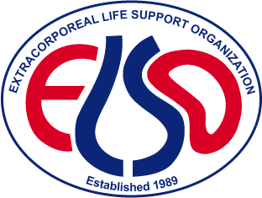
ELSO Award for Excellence in Life Support

How to Interpret your Scores

How do I interpret my Award for Excellence Scores?

- Each question in the application is scored on a 5-point Likert scale, from 0 (Does Not Meet) to 40 (Exceeds), with 20 meeting the standard criteria. Individual question scores are then added to determine a total score.
- In your Award notification letter, you will find your Center’s total score, as well as the breakdown for each category. This allows your Center to benchmark against all Centers of Excellence to identify opportunities for improvement.
- Compare your scores to the others provided in the Award notification letter. Comparing the individual category scores with the averages should give you insight into where deficiencies might exist and identify opportunities for improvement. If your category score is below the score required to meet, that means that you did not provide adequate evidence required to meet the minimum score. If you are above the median score – good work!
- Utilize the Award Evaluation and Improvement Tool to honestly and ruthlessly evaluate your center’s program and how you could improve.

How do we achieve Platinum?

- Review your scores. Do you score below the median score for Platinum centers? This is an area of opportunity for improvement.
- Ensure all your patients have been entered into the ELSO Registry (numbers are double checked against the Registry).
- Refer to the Award Evaluation and Improvement Tool and consider the questions asked within each required section.
  - Honestly and ruthlessly evaluate your provided answer.
  - Did you answer the question fully with a well-developed answer?
  - Did you fully meet the requirements of the question?
  - Did you provide evidence – especially where required?
  - Could you provide further details and explanation?
- Share your quality work with a broader audience so other centers learn from you – and include that in your application.
- Remember that robust high-quality projects require time and planning to complete.

How do we keep the Award for Excellence Designation?

Start working on your next application immediately! It takes consistent effort the entire 3 years to maintain Award status and improve outcomes.

Is it possible to drop down Award status?

Absolutely. Each cycle’s application is evaluated independently and past success does not influence how well a center performs.

